  - Meeting minute Agenda and minutes Template:

Student ID: | CTI20221062
Student Name: | Leonardo Matias Ciarcia
Meeting for scenario
Meeting Agenda and Minutes template: ICTNPL413, ICTNWK561, ICTTEN622, and ICTNWK612
Date/Time: | 22/06/2026
Location: | CTI, Level 8, Room number 04, 333 Adelaide St, Brisbane, QLD 4000
Chairperson: | Dijo
Meeting Attendees:  Full names and roles | - Insert the group photo taken during the meeting and the physically signed attendance sheet here.  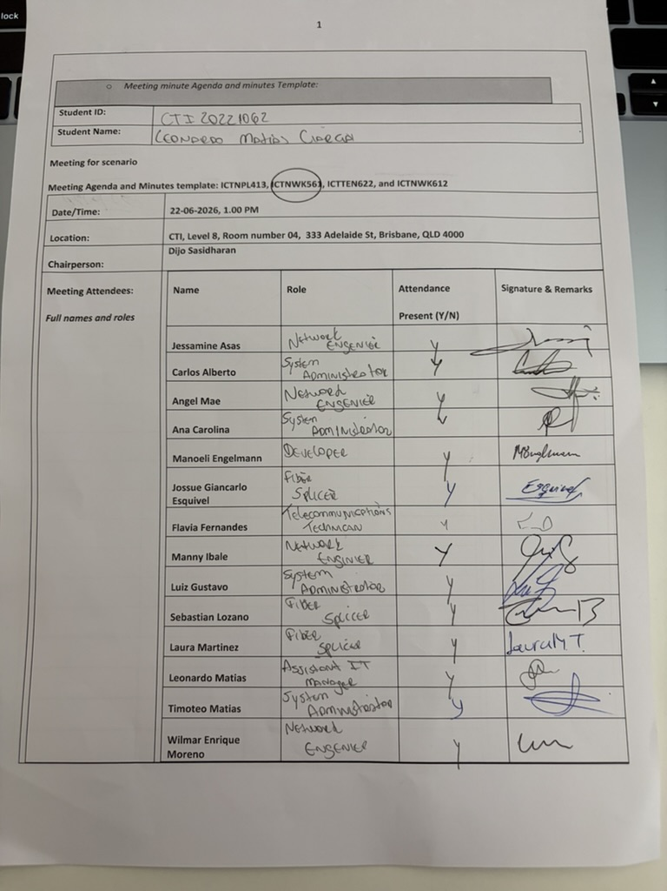  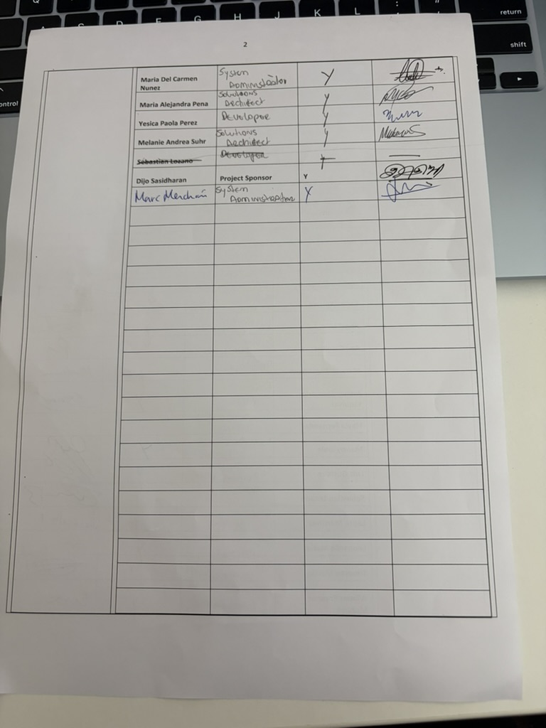  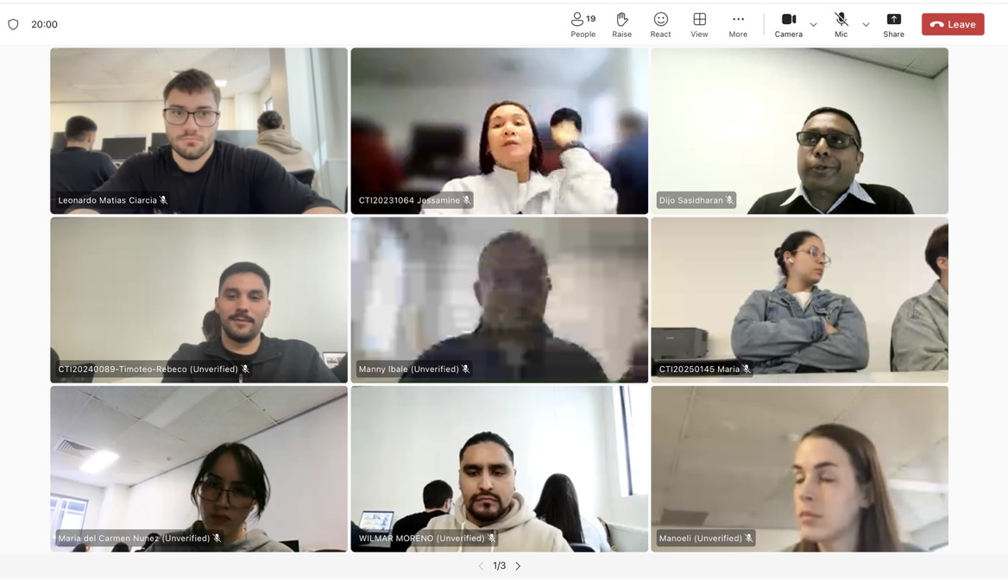  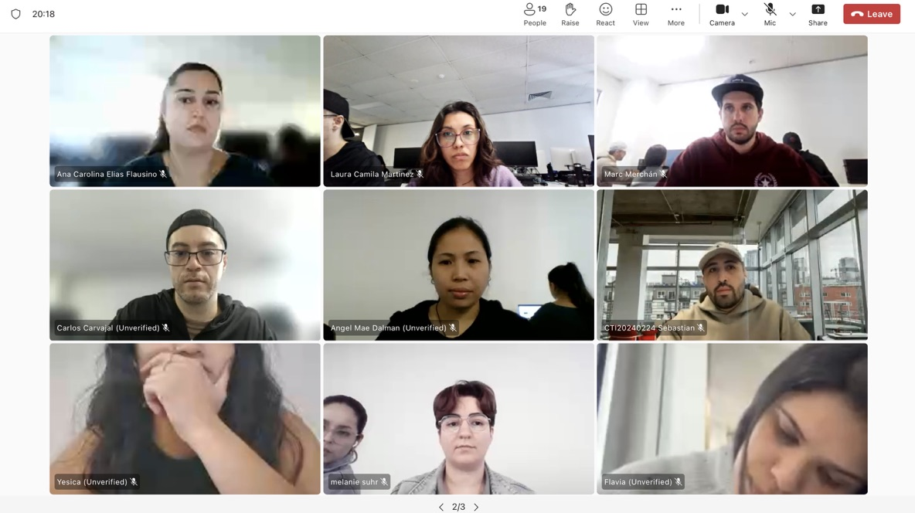  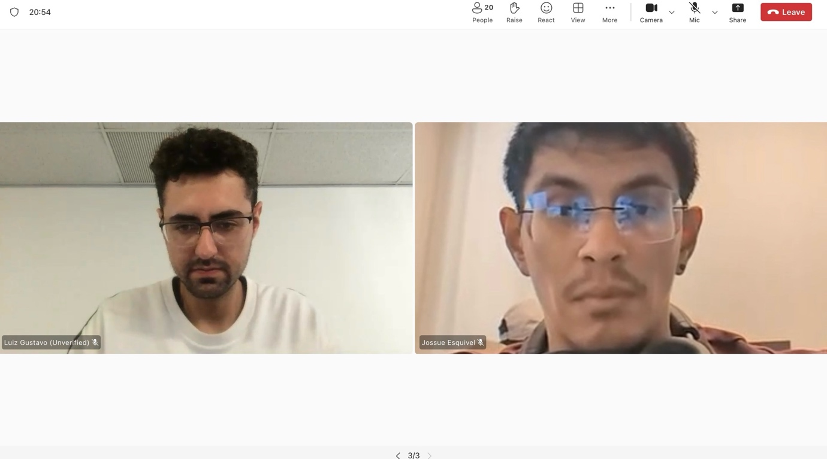
Agenda Item/Topic | Discussion/Activities/Outcomes |  | Action Officer | Target/  Due Date
Welcome | • welcomed the participants and explained the objectives of the wireless network design meeting.  • The participants were advised that the discussion would cover the current network, the client’s current and future needs, the site survey, wireless specifications, modelling, components and client approval.  • The final design was confirmed as Network 3, which provides network services across five levels at the Brisbane campus and supports connectivity to the separate Rookwood campus. |  | Leonardo Ciarcia – Assistant IT Manager | At the beginning of the meeting
(Agenda item 1)  Topic?  - Current network configuration and client requirements | Motion moved by: Leonardo Ciarcia – Assistant IT Manager  Voting and Resolution: The motion was carried. The participants accepted the documented current configuration and client requirements as the baseline for the wireless upgrade. |  | Assistant IT Manager and Network Engineer | Within three business days after the meeting
  Details of discussion/activities (Points Discussed/ Activities completed) | Actions Suggested
  • Reviewed the current network layout, equipment, topology, wireless coverage and carrier connection.  • Identified limitations relating to wireless coverage, available network capacity, scalability and support for the two additional classroom levels.  • Documented A-Plus Institute’s requirement to expand the Brisbane campus from three existing levels to five levels.  • Confirmed the need for reliable wired and wireless access for staff, students and guests.  • Reviewed future requirements, including increased enrolments, additional wireless devices, secure remote access and connectivity with the Rookwood campus.  • Confirmed that the server room remains on Existing Level 1 and does not represent a sixth level. | • Update the current network configuration and topology records.  • Document the client’s current and future wireless requirements.  • Confirm expected user and device numbers for each of the five levels.
(Agenda item 2)  Topic?  - Wireless site survey and radiofrequency assessment | Motion moved by: Leonardo Ciarcia – Assistant IT Manage  Voting and Resolution: The motion was carried. The proposed access point locations and site survey activities were accepted for further modelling and testing. |  | Wireless Network Engineer and WHS Representative | Before finalising the wireless specifications
  Details of discussion/activities (Points Discussed/ Activities completed) | Actions Suggested
  • Reviewed the site survey process for all five Brisbane levels.  • Identified building materials, walls, classroom layouts, user density, equipment locations and possible signal obstructions.  • Considered potential radiofrequency interference from neighbouring wireless networks, electronic equipment and overlapping wireless channels.  • Reviewed the locations of data outlets, cabling routes, power supplies, access switches and wireless access points.  • Confirmed that the survey must be completed safely and with minimum disruption to staff and students.  • Recorded proposed access point locations and areas requiring coverage and performance testing. | • Record wireless signal strength and interference at representative locations on every level.  • Confirm the availability of power and structured cabling at each proposed access point position.  • Update the site survey report with identified risks and recommended resolutions.
(Agenda item 3)  Topic?  - Wireless upgrade specifications and network modelling | Motion moved by: Leonardo Ciarcia – Assistant IT Manage  Voting and Resolution: The motion was carried. The centralised wireless design and modelling process were approved. |  | Wireless Network Engineer and Assistant IT Manager | Before implementation testing begins
  Details of discussion/activities (Points Discussed/ Activities completed) | Actions Suggested
  • Reviewed the proposed installation of one managed wireless access point and one access switch per Brisbane level.  • Confirmed that the wireless access points would be centrally managed through a wireless LAN controller.  • Discussed separate wireless access for staff, students and guests using VLAN and SSID segmentation.  • Reviewed wireless security requirements, including strong authentication, encryption and restricted guest access.  • Considered channel selection, frequency use, signal overlap, roaming, user density and expected traffic growth.  • Reviewed the Packet Tracer model used to test wireless association, DHCP addressing, default gateway assignment and access to authorised network resources.  • Confirmed that modelling should account for increased enrolments and future growth. | • Test the wireless design under expected user and traffic conditions.  • Verify DHCP, SSID, VLAN and security settings for each user group.  • Record modelling results and revise access point settings where required.
(Agenda item 4)  Topic?  - Network components, implementation planning and client presentation | Motion moved by: Leonardo Ciarcia – Assistant IT Manage  Voting and Resolution: The motion was carried. Network 3 was accepted as the preferred enterprise wireless solution, subject to completion of documentation and client sign-off. |  | Assistant IT Manager, Procurement Officer and Project Manager | Before procurement and final client sign-off
  Details of discussion/activities (Points Discussed/ Activities completed) | Actions Suggested
  • Reviewed the final Network 3 component list, including two Layer-3 core switches, one access switch and one access point per level, a server switch, wireless LAN controller and representative user devices.  • Confirmed the supporting server services, including DHCP, DNS, authentication, file storage, backup and network monitoring.  • Reviewed the use of 2911 routers for routing, NAT, VPN and access control functions.  • Confirmed that 3TTech would provide the external service supporting Brisbane and Rookwood connectivity.  • Discussed compatibility, vendor specifications, equipment capacity, sustainability, economic running costs and future expansion.  • Presented the final wireless design, its benefits, expected performance, limitations and security considerations to the client representative. | • Finalise the component and equipment schedule.  • Complete the wireless implementation and testing plan.  • Record client feedback and obtain endorsement of the final wireless design.
Summary | Overall Summary: The meeting reviewed the current network, current and future client needs, site survey results, wireless upgrade specifications, network modelling, equipment selection and presentation of the final design. The selected design supports all five Brisbane levels and future inter-campus connectivity.  Decision/s:  • Implement centrally managed enterprise wireless networking.  • Install one managed access point and access switch per Brisbane level.  • Separate staff, student and guest access through VLANs and SSIDs.  • Use Network 3 as the final wireless design.  • Complete testing before implementation approval.  Action/s if any:  • Finalise the site survey report.  • Complete the wireless modelling and test results.  • Finalise the equipment list and implementation plan.  • Obtain client feedback and endorsement. |  | Leonardo Matias Ciarcia | 22/06/2026
Next Meeting time/date | Was 19/08/2025 |  | Leonardo Matias Ciarcia | 22/06/2026
Meeting closed at: | 2PM |  | Leonardo Matias Ciarcia | 22/06/2026
Minutes are a true and accurate record of the meeting | Approved/confirmed by: (who?)  Dijo Sasidharan |  | Dijo | 22/06/2026
Signature of attendee 1: Dijo Sasidharan |  | Signature of attendee 3: Leonado Matias Ciarcia

